[aytanasadova/AWS-developer-intensive-course (github.com)](https://github.com/aytanasadova/AWS-developer-intensive-course)

Creating instance (**Application and OS Images (Amazon Machine Image))**

Creating instance (**Instance type)**

Creating instance (Creating instance (**Instance type))**

Creating instance (Network settings )

Creating instance (Advanced details)

**After user-data effect**

**Connect to instance**

To prepare the LAMP server

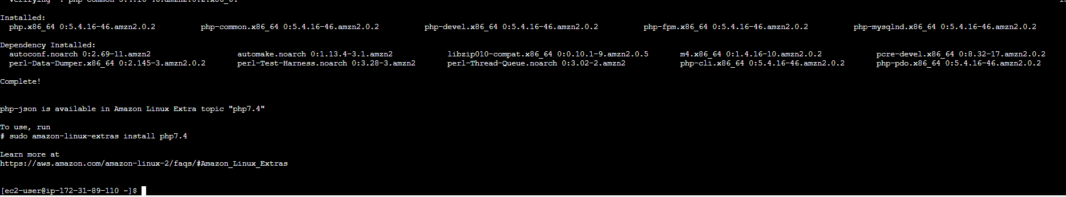

Command: sudo amazon-linux-extras install -y lamp-mariadb10.2-php7.2 php7.2

To see version of Amazon Linux :

Command :[ec2-user ~]$ **sudo yum install -y httpd mariadb-server**

Test your web server. In a web browser, type the public DNS address (or the public IP address) of your instance. If there is no content in /var/www/html, you should see the Apache test page.

To set file permissions

1. Add your user (in this case, ec2-user) to the apache group.

Change the group ownership of /var/www and its contents to the apache group.

1. *sudo chown -R ec2-user:apache /var/www*
2. *sudo chmod 2775 /var/www && find /var/www -type d -exec sudo chmod 2775 {} \;*
3. find /var/www -type f -exec sudo chmod 0664 {} \;

Now, ec2-user (and any future members of the apache group) can add, delete, and edit files in the Apache document root, enabling you to add content, such as a static website or a PHP application.

Secure the database server

1. (Optional) If you do not plan to use the MariaDB server right away, stop it. You can restart it when you need it again.

[ec2-user ~]$ **sudo systemctl stop mariadb**

1. (Optional) If you want the MariaDB server to start at every boot, type the following command.

[ec2-user ~]$ **sudo systemctl enable mariadb**

 (Optional) Install phpMyAdmin

[ec2-user ~]$ **sudo systemctl is-enabled httpd**

Mount additional data volume usable:

